Scripting Task:
- Create a shell script to print the HTTP error code of guvi.in & print, the success/failure message based on the error code response
- Given a file, replace all occurrence of the word "give" with "learning" from 5th line till the end in only those lines that contain the word "welcome"
1st one:
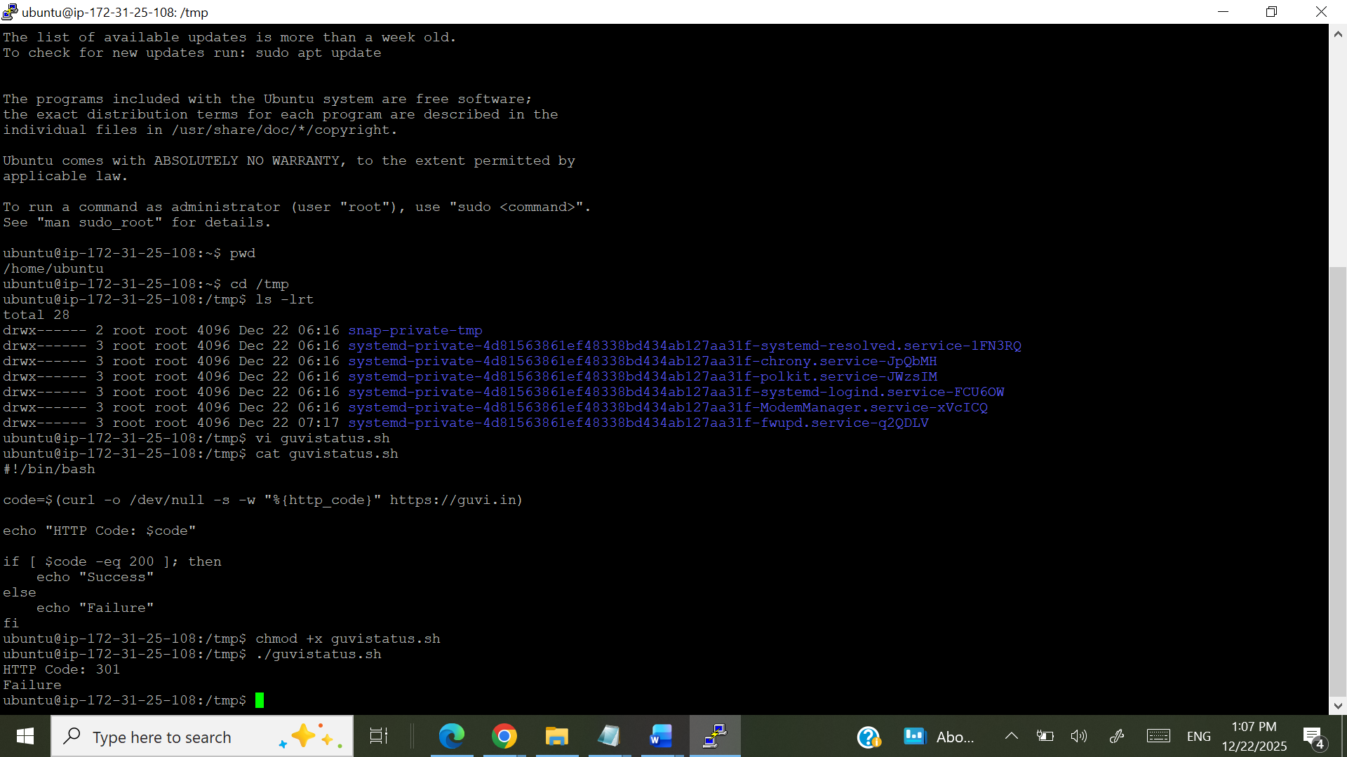
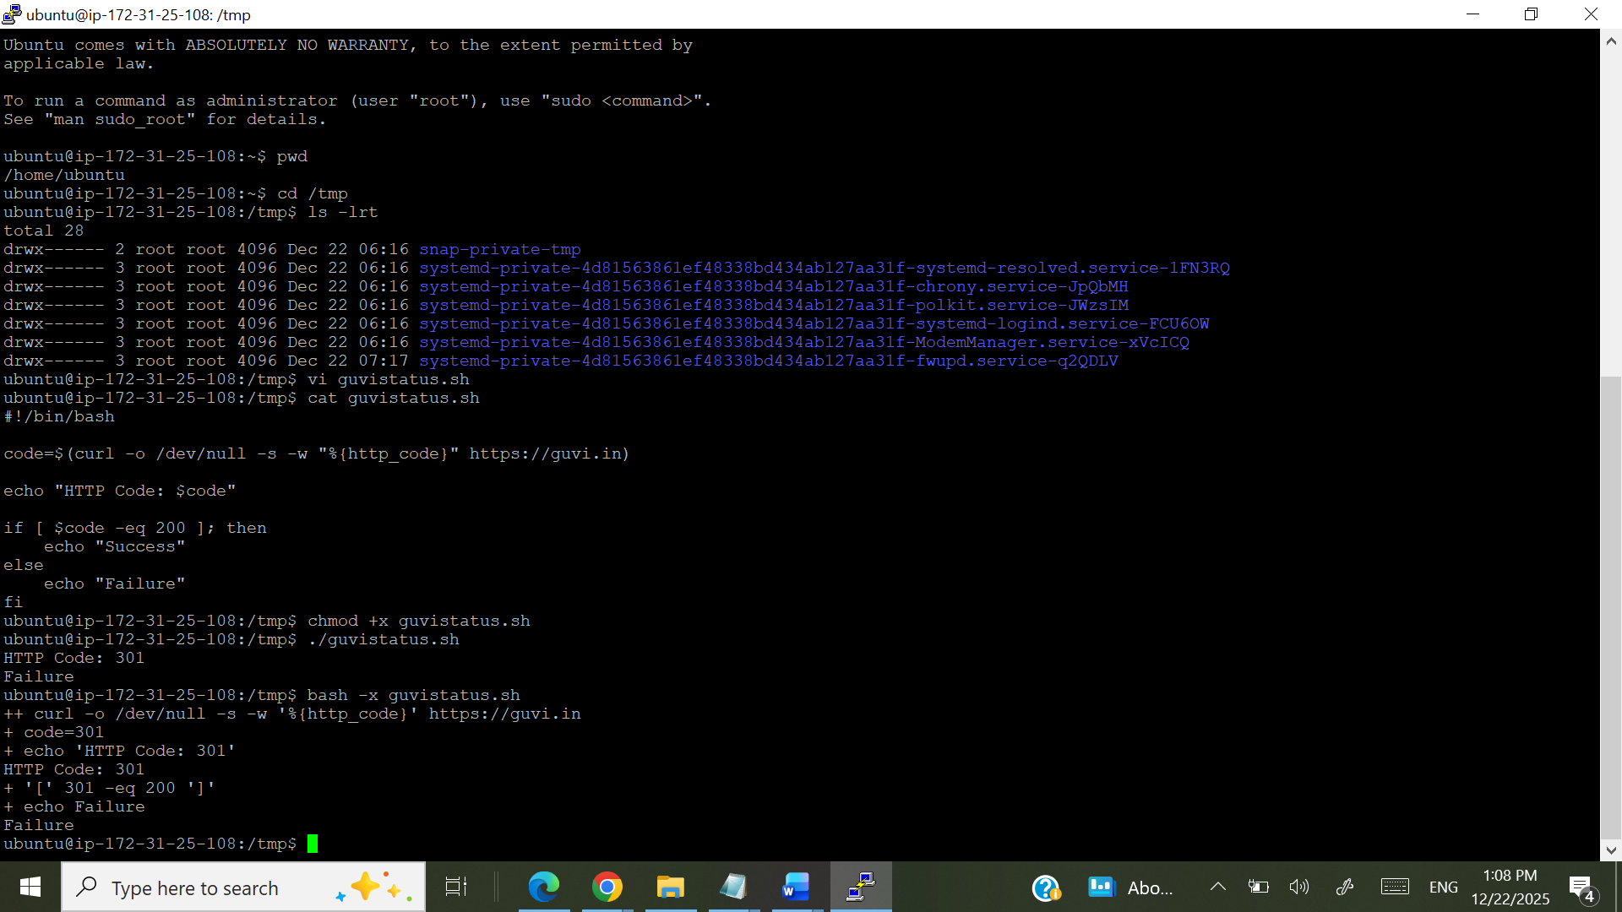
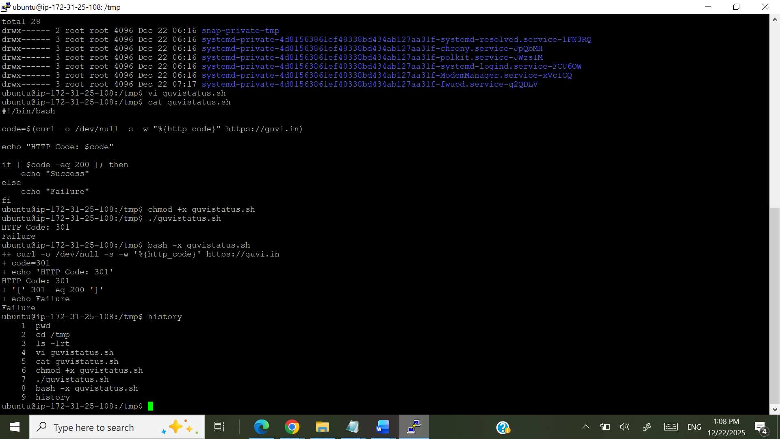
2nd one:
